**Appendices J**

**Singleton Pattern**

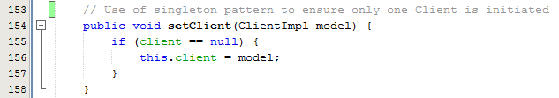

Fig. 1 – Extract from HomeForm, setClient()

As you can see from Fig. 1, I have used the singleton pattern within the HomeForm class, which is a class that represents the home screen graphical user interface (GUI). I decided to use the singleton pattern for each GUI class as well as a few other instances, to ensure that only 1 instance of the ClientImpl class can be assigned to a Client variable.

This is because, a GUI class should only be used for 1 client only, and therefore should not be able to be reassigned to a different Client instance.